SESSION 2
Navigating Sage 50 & Entering Opening Balances
FSSU Sage 50 Accounts – Practical Training Course
Learning Objectives
By the end of this lesson, you will be able to:
- Find your way around the Sage 50 desktop and menu bar
- Enter your school's opening balances correctly
- Set and understand the processing date
- Enter uncleared bank account transactions
- Import customer and supplier details
- Enter your annual budget

2.1 Getting Familiar with the Sage 50 Screen Layout
The Sage 50 Accounts desktop is the main window in the software — it's the starting point for every task, so it's worth taking a moment to learn its layout.
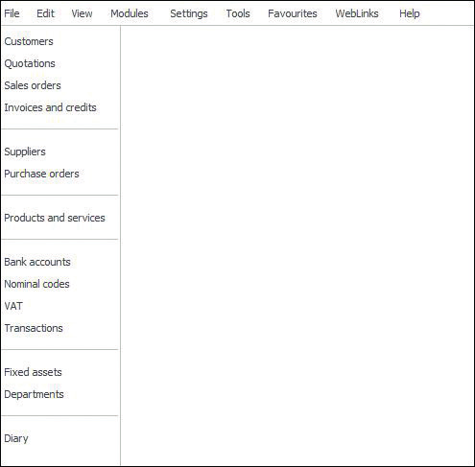
Figure 1 — The Sage 50 Accounts desktop
- Title bar — shows the software name and the company currently open.
- Menu bar — contains each menu's options. Press ALT + the underlined letter to open a menu quickly, e.g. ALT+T for Tools.
- Navigation bar — down the left side, gives quick access to each module (Customers, Suppliers, Bank, Nominal, and so on).
- Work area — the main pane where you enter and view data, in List, Process map or Dashboard view.
TIP: Throughout this course we assume you're using List view, since that's what most of the step-by-step instructions describe.

2.2 The Menu Bar
The menu bar sits at the top of the desktop and controls most of Sage 50's functions — from opening a module to running a report.
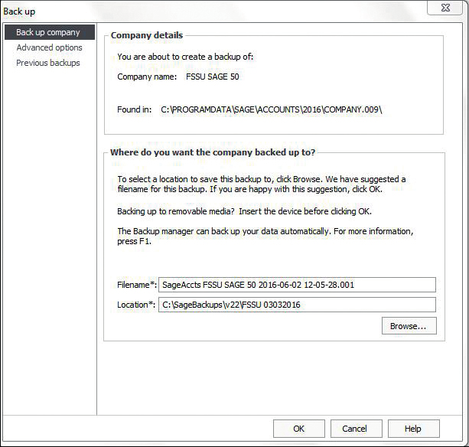
Figure 2 — The Sage 50 menu bar
- File — open, back up and maintain your company data.
- Settings — company preferences, financial year, currency and access rights.
- Modules — Customers, Suppliers, Bank, Nominal Ledger and more, matching the navigation bar.
- Tools — options, global settings, and utilities such as the period end routines.

2.3 Entering Opening Balances
Opening balances bring your existing account balances into Sage 50 as your starting point, so that every transaction from that date forward is recorded in the new system.
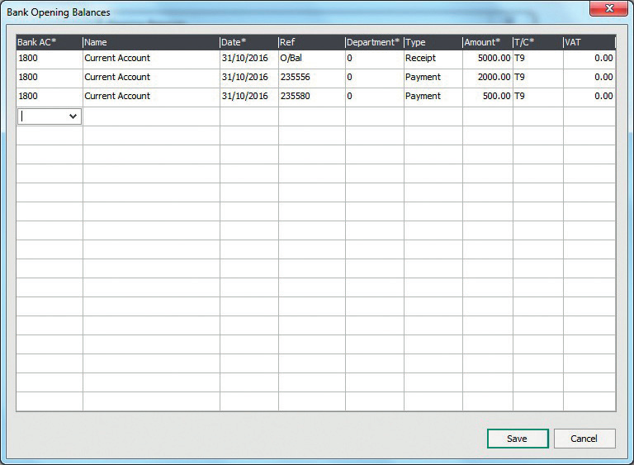
Figure 3 — Entering an opening balance
- Go to the relevant module (Customers, Suppliers, Bank or Nominal) and select the account.
- Choose the Opening Balance (O/B) option for that account.
- Enter the balance as at your chosen start date, using the correct debit or credit side.
TIP: Opening balances should always be entered before you post any everyday transactions, and are best agreed with your accountant or the FSSU beforehand.

2.4 Setting the Processing Date
The processing date is the date Sage 50 uses by default when you post a new transaction. Setting it correctly saves you from having to change the date manually on every entry.
- Go to Settings > Change Program Date.
- Enter the date you want to use as your default posting date.
- The processing date, along with the software date and financial year start, is shown on the status bar at all times.
TIP: Check the processing date each morning, especially just after a month-end or year-end, so you don't accidentally post transactions into the wrong period.

2.5 Entering Uncleared Bank Account Transactions
When you first move to Sage 50, there will usually be cheques or lodgements from the old system that haven't yet cleared the bank. These need to be entered so your bank reconciliation is accurate from day one.
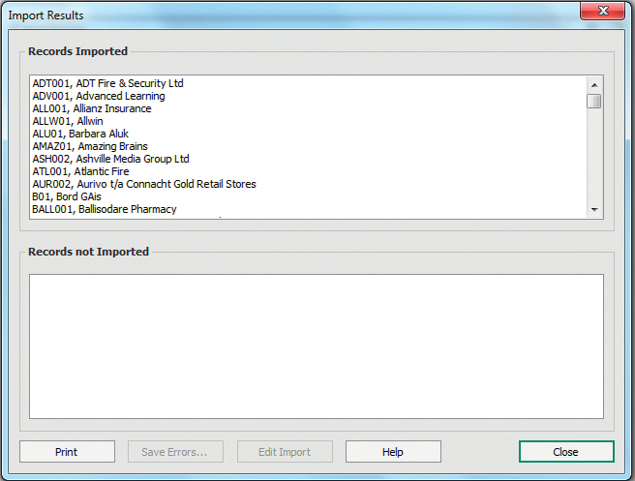
Figure 4 — Entering an uncleared bank transaction
- Open the Bank module and select the relevant bank account.
- Enter each uncleared cheque or lodgement individually, using its original date and reference.
- Leave these transactions unreconciled until they actually appear on your bank statement.
TIP: Entering uncleared items accurately means your very first bank reconciliation in Sage 50 will balance properly.

2.6 Importing Customer and Supplier Details
Rather than typing in every customer and supplier by hand, Sage 50 lets you import them in bulk from a spreadsheet — a big time-saver when you're first setting up.
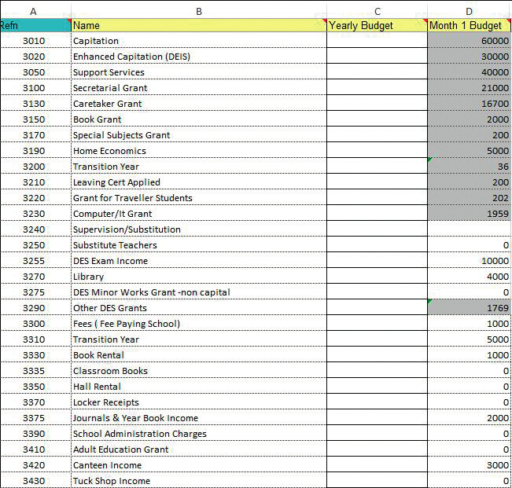
Figure 5 — The Import wizard
- Go to File > Import.
- Choose the record type — Customers or Suppliers.
- Select your prepared CSV file and map its columns to the correct Sage 50 fields.
- Review the import summary carefully before confirming, since incorrect mappings can create bad data.
TIP: Take a backup before running any import — if the file is mapped incorrectly, restoring the backup is far quicker than correcting hundreds of records by hand.

2.7 Entering the Budget
Budgets let you compare actual income and expenditure against what was planned — a key part of the reports your Board of Management will review.
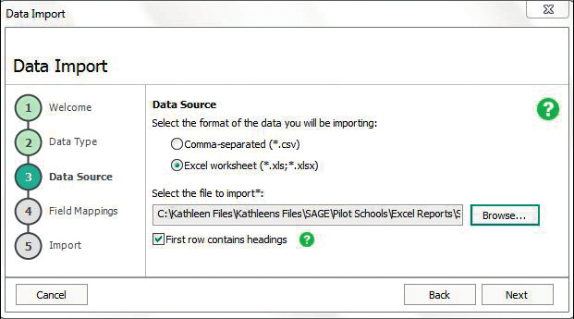
Figure 6 — Entering a budget in the Nominal Ledger
- Open the Nominal Ledger module and select the nominal code you want to budget.
- Choose the Budget option and enter the amount for each period (usually monthly).
- Repeat for each income and expenditure code agreed with your Board of Management.
TIP: Enter your budget as soon as it's approved — the Board reports compare actuals to budget automatically once it's in place.
Key Takeaways
- Learn the desktop layout and menu bar first — everything else in Sage 50 builds on this navigation.
- Enter opening balances and uncleared bank items carefully and before any live transactions, so your first reconciliation balances.
- Use Import for bulk customer/supplier setup, but always back up first and check the mapping.
- Enter your budget promptly so Board of Management reports compare actual figures against it correctly.
Next: complete the Session 2 quiz to finish the course.

