SESSION 1 · PART A
Installing & Configuring Sage 50 Accounts
FSSU Sage 50 Accounts – Practical Training Course
Learning Objectives
By the end of this lesson, you will be able to:
- Install Sage 50 Accounts on a single computer or a school network
- Register your software using your Serial Number and Activation Code
- Restore the FSSU Chart of Accounts to set up your school's data file
- Install the FSSU Board of Management report suite
- Customise your school's name, financial year and currency settings

1.1 Installing Sage 50 Accounts
Before you install anything, close every other program running on the computer. Installing on top of open software is one of the most common causes of a failed install.

Installing on a single computer
- Locate the email Sage sent you and print it — it contains your Serial Number and Activation Code, which you'll need shortly.
- Follow the download link in that email and choose the Full Program option, then Install Full Version of the software.
- Accept the licence terms and conditions, tick the checkbox, and select Next.
- When asked which files to install, choose Standard (Recommended) and select Next.
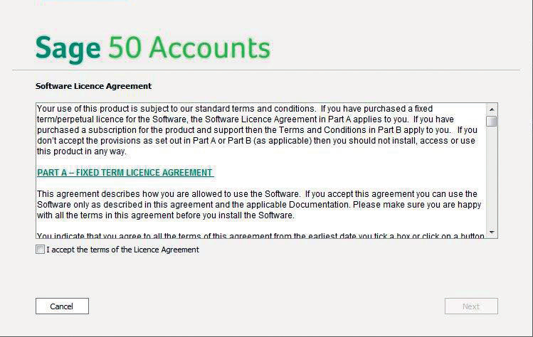
Figure 1 — The Sage 50 Accounts installation wizard
The installer proposes a default folder for the program files. On a 64-bit machine this is normally C:\Program Files (x86)\Sage\Accounts; on a 32-bit machine it is C:\Program Files\Sage\Accounts. Unless your school's IT policy says otherwise, accept the default location.
- Select Yes, begin installation. This usually takes only a few minutes.
- When it finishes, select Launch Sage 50 Accounts to open the software for the first time.
TIP: If the installation stalls or throws an error partway through, restart the computer and try again with all other applications closed — including anything running quietly in the system tray.

1.1.2 Registering your software
The first time you open Sage 50 Accounts, the Software Registration window appears automatically.
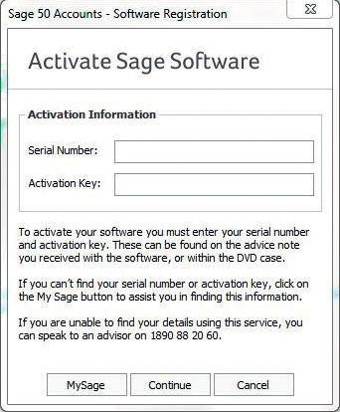
Figure 2 — The Sage 50 registration window
- Enter the Serial Number and Activation Key exactly as they appear in your Sage email.
- Select Continue.
Once accepted, you'll see a confirmation that registration was successful, and the software is ready for your school's data to be set up.
TIP: Keep the original Sage email safe (or save a PDF copy) — you may need the serial number again if you ever reinstall the software on a new computer.

1.2 Installing on a School Network
Many schools run Sage 50 Accounts from a shared office computer over the network rather than on one machine alone. In that setup, the software and the data files live on the server, and any other office computer connects to the server to read and write the same accounts.
- Install Sage 50 Accounts on the server using exactly the same steps as a single-computer install.
- Share the data folder on the server so other computers on the network can see it. The folder is normally located at C:\ProgramData\Sage\Accounts\20xx.
- Give the shared folder Full Control on the Share and Modify permissions on its contents, so the software can read and write data properly.
TIP: Sharing folders and permissions is an IT administration task. If you're not confident doing this yourself, ask your school's IT support person, or contact Sage Technical Support.

1.3 Installing the FSSU Chart of Accounts
Once Sage 50 is installed, you need a company data set for your school. Rather than building one from scratch, the FSSU provides a ready-made template company, pre-configured with the correct chart of accounts for schools.
- Save the FSSU company file that was emailed to you to your desktop.
- Open Sage 50 and choose to set up a new company.
- Log in with the username MANAGER and leave the password blank for now.
- Choose Restore data from a backup file, browse to the saved FSSU file on your desktop, and restore it.
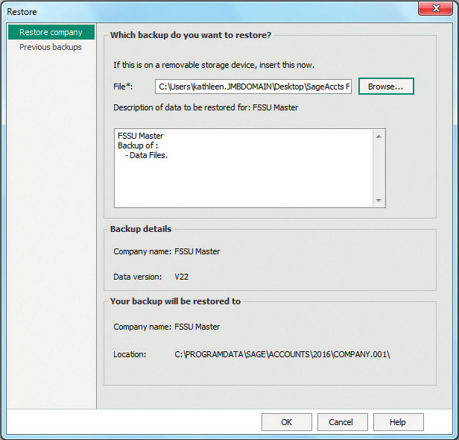
Figure 3 — Restoring the FSSU company data file
If you use the multi-user version of Sage 50, you'll be prompted to approve sharing the newly restored data across the network — accept this so other authorised users can access the accounts.

1.4 Installing the FSSU Board of Management Reports
Alongside the day-to-day accounts, your Board of Management needs a set of standard financial reports. The FSSU has designed a suite of Excel reports that link directly to your Sage 50 data and refresh automatically each time they're generated.
- Income and Expenditure Account — actual activity against budget, over the past year
- Balance Sheet — actual position for the past year
- Income and Expenditure, Month by Month — actual figures
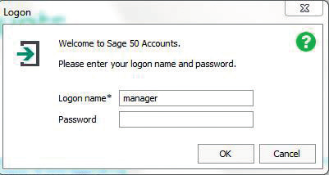
Figure 4 — Installing the FSSU Board of Management report templates
Save these Excel report templates to the desktop so they're easy to find each month.
TIP: The first time you open Sage 50, a 'Welcome, let's get started' page appears. To stop it showing every time, go to Tools > Options > View > Initial View > Global Settings and untick 'Display the welcome page'.

1.5 Customising School Settings & Preferences
With your data file restored, spend a few minutes checking that the core company details are correct before you start entering real transactions.
- Company name & address — go to Settings > Company Preferences > Details, and enter your school's name (including the school roll number) and address.
- Financial year — go to Settings > Financial Year and confirm the start month. For schools, the financial year normally runs from 1 September to 31 August.
- Currency — go to Settings > Currency and confirm it is set to Euro.
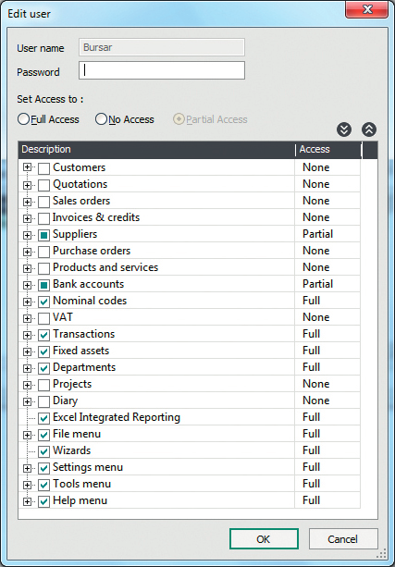
Figure 5 — Confirming currency settings
TIP: Currency cannot be changed later, so double-check it before you enter any transactions.
Key Takeaways
- Always close other software before installing, and keep your Serial Number & Activation Code handy.
- The FSSU-supplied company file gives you a ready-made, school-specific Chart of Accounts — restore it rather than building one from scratch.
- Check your company name, financial year and currency immediately after set-up, since currency can't be changed later.
Next: continue to Part B — Security, Backup & Data Maintenance, then complete the Session 1 quiz.

